Marketplanet Purchase Platform – Postępowania
Suppliers/Contractors' manual

To:
Suppliers/Contractors

Version 3.0
Martyna Kopka
18.12.2020

Table of contents

Equipment requirements 2
Introduction 3
Registration of the Contractor 3
Registration of the Contractor - no account on the Marketplanet OnePlace 3
Registration of the Contractor – when you have an account on the OnePlace 7
Logging in 8
Public Zone 12
System navigation 12
Supplier Qualification process 16
Filling in the qualification form 16
Making offers process 19
Participating in the proceedings 19
Proceedings overview 20
Heading of the Purchase Request (RFX) 20
Status tab 21
Project documentation tab 22
Offers tab – making an offer 22
Offers tab – filling in the form in the Platform 25
Offers tab – generating an excel template and importing the completed file 26
Making an offer in the procedures with many positions 26
Offers modification and withdrawal 26
Offer encryption 27
Electronic signature 28
Questions and answers tab 30

Equipment requirements

The minimum hardware requirements necessary for the proper functioning of the Platform:
- browsers of your choice (with the latest updates installed):
  - MS Internet Explorer 10.0 (or newer) with Active X support,
  - Java-enabled Firefox, encryption power: 128bit..,
  - Chrome.
- NOTE: Other browsers, such as Opera, Safari or Microsoft Edge are not supported and using them may hinder or block the ability to place an electronic signature on the Marketplanet Platform.
- Internet connection: min. 1 Mb/s per computer (broadband Internet connection recommended).
- No blocking of pop-up windows in the browser.
- PC class computer with Microsoft Windows 7 / Windows 8 / Windows 10 operating system installed (version currently supported by the manufacturer).
- Permissions on the computer to run Java applets.
- 32-bit JAVA 32 bit version 1.8.0_191 or later, allowing the user to accept session cookies and supporting encryption;.
- The current version of the JAVA bootable environment can be downloaded from here: https://www.java.com/pl/download/ You can check your version in accordance with the instructions available at: https://www.java.com/pl/download/help/version_manual.xml.
- A cryptographic card reader, connected or built-in to the computer, issued by the issuer of the certificate used by the Contractor (the card present in the reader during signing).
- Current drivers for the cryptographic card reader installed on the workstation (manufacturers' websites, installed software dedicated to the signature).
- Qualified certificate installed on the computer on which the Contractor will log in to the account (the certificate must be visible in the Windows certificate logic store called "Personal"). In order to verify the fulfillment of this requirement, run the "Control Panel" and then go to Internet options, select the "Content" tab and click the "Certificates" option.

All characters processed by the platform are coded using the UTF-8 coding system.
The connection between the user and purchasing platform is based on the HTTPS data format and TLS encryption.
The time of data reception by the purchasing platform is generated based on the local time of the server, synchronized with the appropriate input time source.

Introduction
These instructions are made for users making the offers among the proceedings conducted by one of the Veolia Group companies in Poland. The document contains a manual and a description of functions available on the Marketplanet Purchase Platform.

The MarketPlanet Purchase Platform enables the Supplier:
1. Registration in the system,
2. Joining the proceedings,
3. Preview of the proceedings,
4. Recording and submitting the offer,
5. Asking a question in the proceedings,
6. Answer to a question put by the Orderer,
7. Possibility of participating in an electronic auction,
8. Joining the supplier qualification process.

Registration of the Contractor

Registration of the Contractor - no account on the Marketplanet OnePlace

If the contractor does not have an account in the Marketplanet OnePlace system, he should register using the registration form. In order to display the form, select one of the 2 options below:
- Click on the Log in button and then on the login screen click on the Create a free account button on https://oneplace.marketplanet.pl.
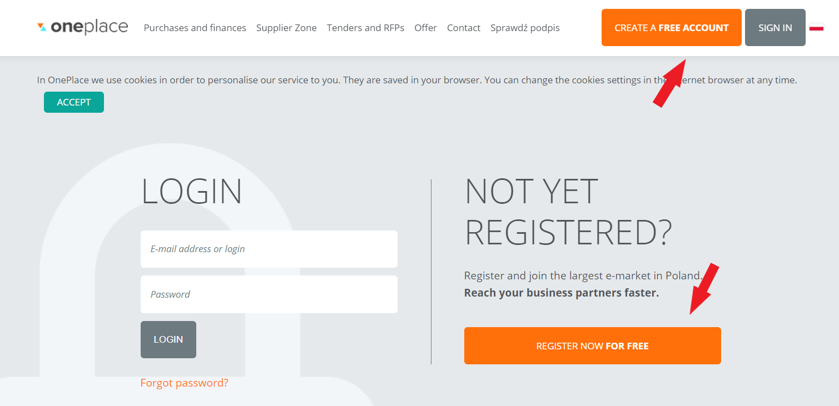

- click on the Log in button at https://platformazakupowa.veolia.pl/ then select the appropriate zone - Supplier Zone (1) and click the Register button (2).
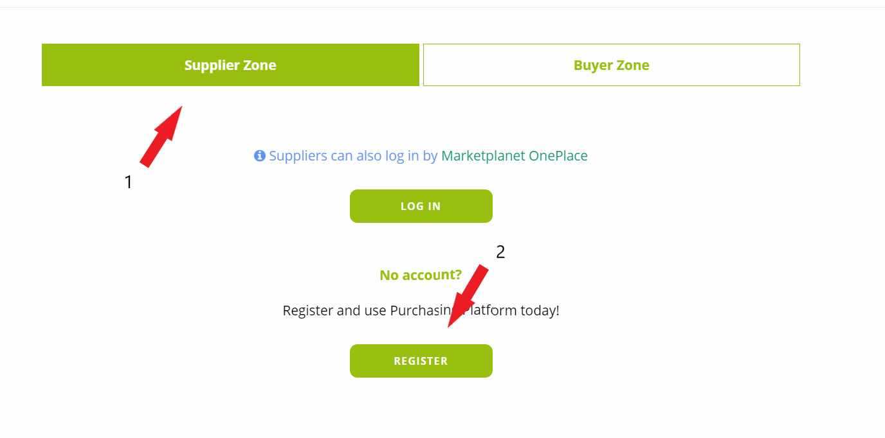
After one of these actions is completed, a registration form will be displayed. The form is presented on the screen below.

The registration form is divided into two sections:
Supplier data - enter the basic supplier data in this section (Supplier name, Tax ID, Categories of products/services supplied, etc.).
User data - this section should contain the Provider's user data, which will represent the Provider. (Login, e-mail, etc.)
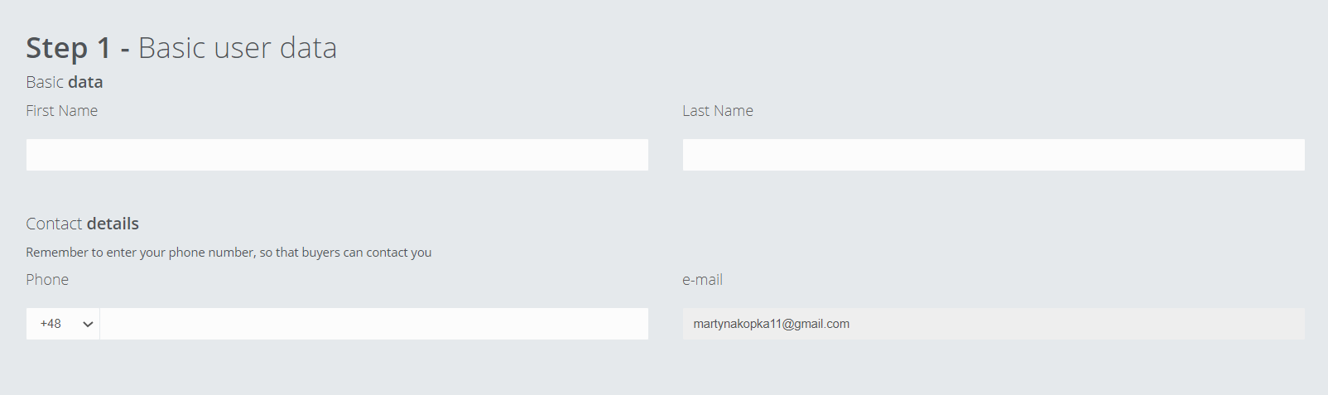
Basic User Data

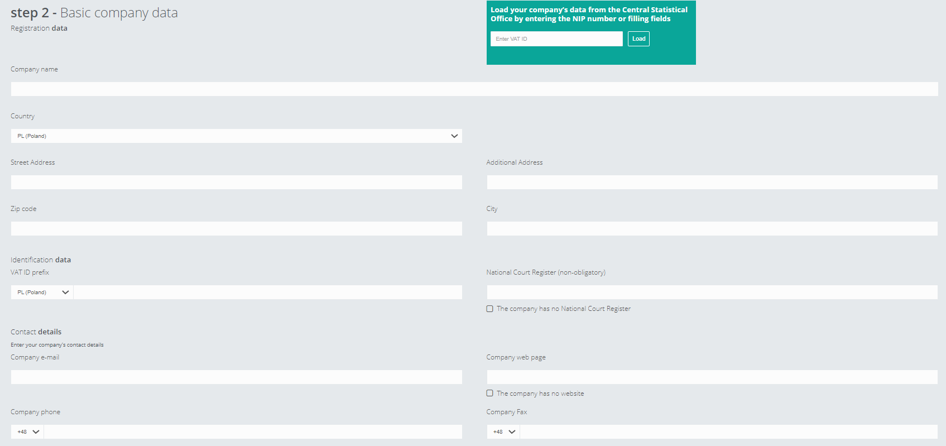
Basic Company Data

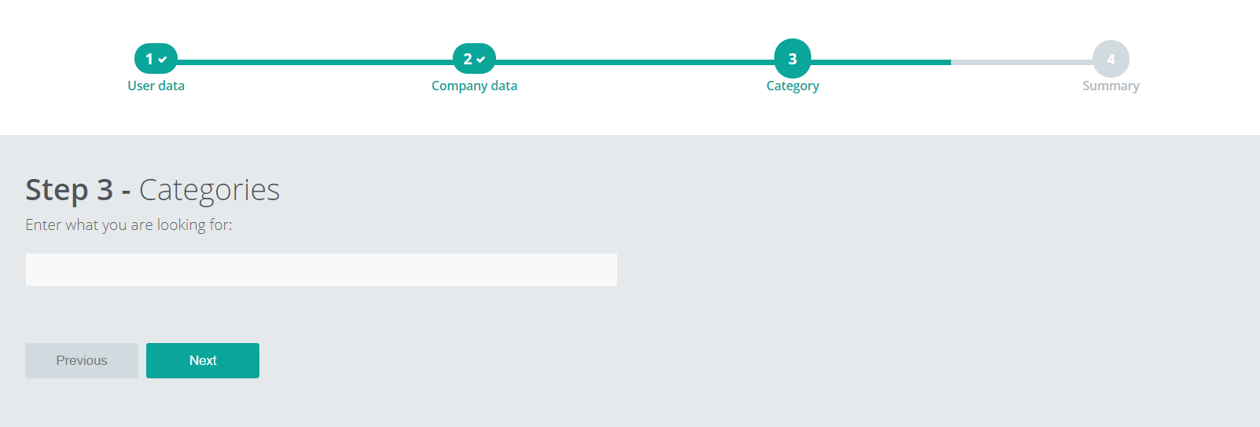
Selection of query categories

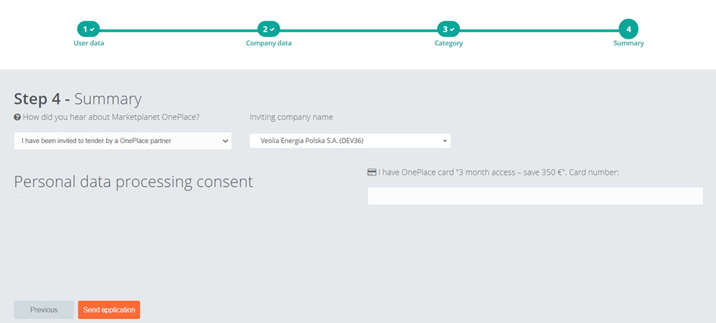
Summary section - send in a proposal

In the section “Other data” please add an annex.
Below the box with the obligatory addition of an annex there is a "checkbox" with description: "I agree to the processing of my personal data by the aforementioned entities for marketing purposes, including receiving commercial information sent by Otwarty Rynek Elektroniczny S.A. to the e-mail address provided". If the "checkbox" is not checked, it will not be possible to send the registration application.
The administrator will send you an e-mail accepting the application with a temporary password to the system after receiving the application and verifying the data. You should change it at your first logging in.

Registration of the Contractor – when you have an account on the OnePlace

If the contractor has an account in the Marketplanet OnePlace system but does not yet have an account on the Veolia Purchasing Platform, he should enter the Services section of the menu (1), then search for the Veolia Platform, e.g. using the search engine (2) and use the Enter button (3) to connect the account. It is important to select an account from the Purchase Platforms section but not from the e-Procurement area below.
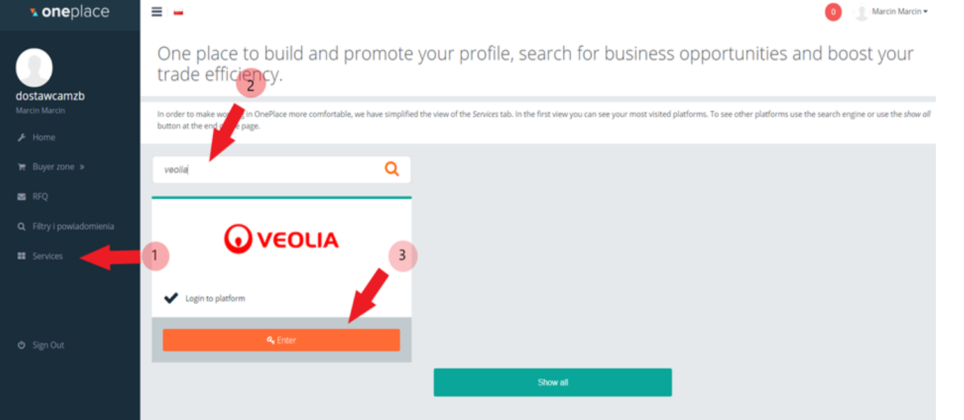

Logging in

Click on the Sign In link in the upper right-hand corner above the workbox to log in to the System.
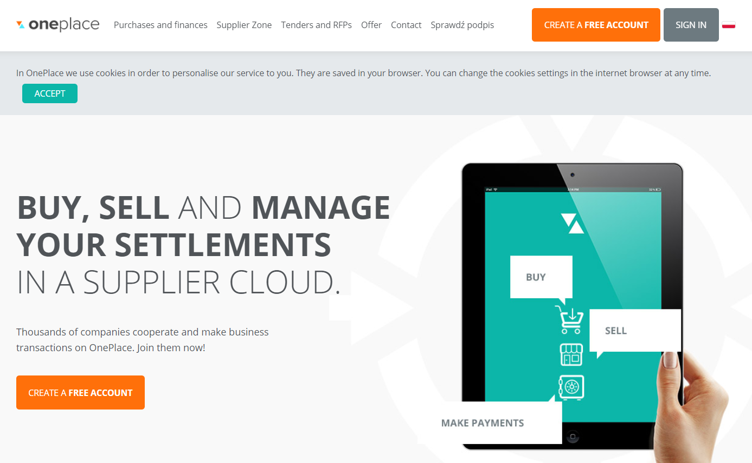
When you select the Sign In button, the login screen opens.
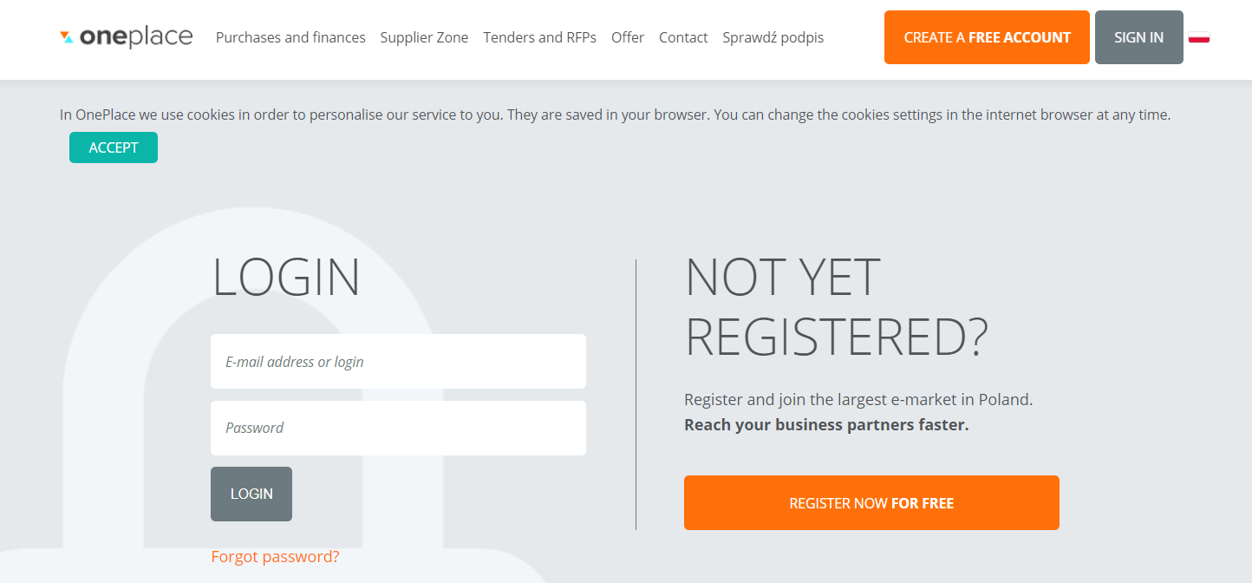
After logging in to the application, the user will have access to sections available for logged-in suppliers, for example, sections:
- Home page,
- All questions,
- Filters and notifications,
- Services,
- Settings.
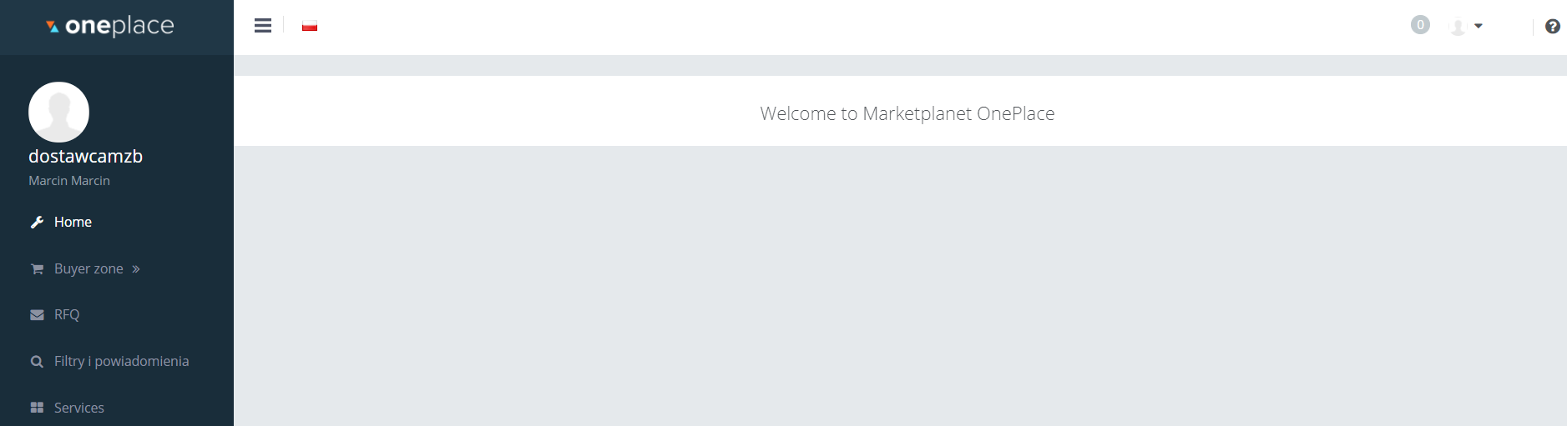

In order to check the current proceedings, the Contractor must select the Services button from the menu visible on the left side of the screen.

Next, click on the icon of the Purchaser. If it is your first time, there will appear the Read the content of consent button.
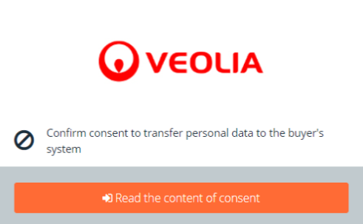

When you click on this button, the content of the consent will open and you will have to agree to go on.
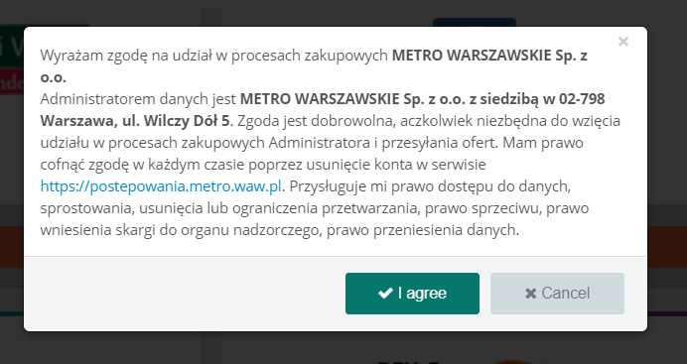

Now, every time you log in, you will see the Enter option next to the icon of the Purchaser.
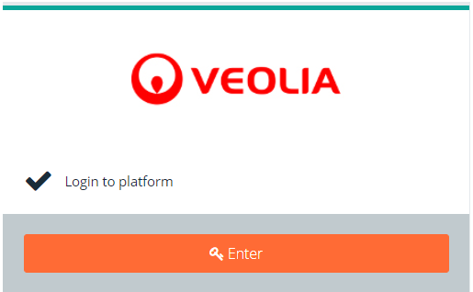

For the first time there will be opened a screen with the acceptance of the Purchase Platform regulations. Click on the Consents (1) to read them. Then tick the checkbox next to the Consents (2) and save (3). From here you can withdraw your acceptance at any time by unchecking the checkbox (2) and saving (3). It is also possible to close the account and close the account with the simultaneous sending of a request for forgetting and exporting personal data to CSV format.
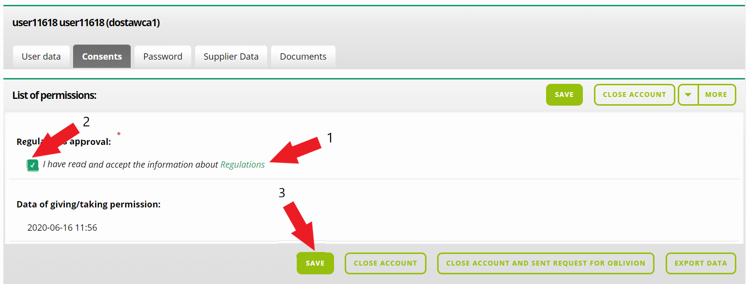

You can always return to the above screen by clicking on the icon (1) and selecting My Profile (2) and then going to the Consent tab (3).
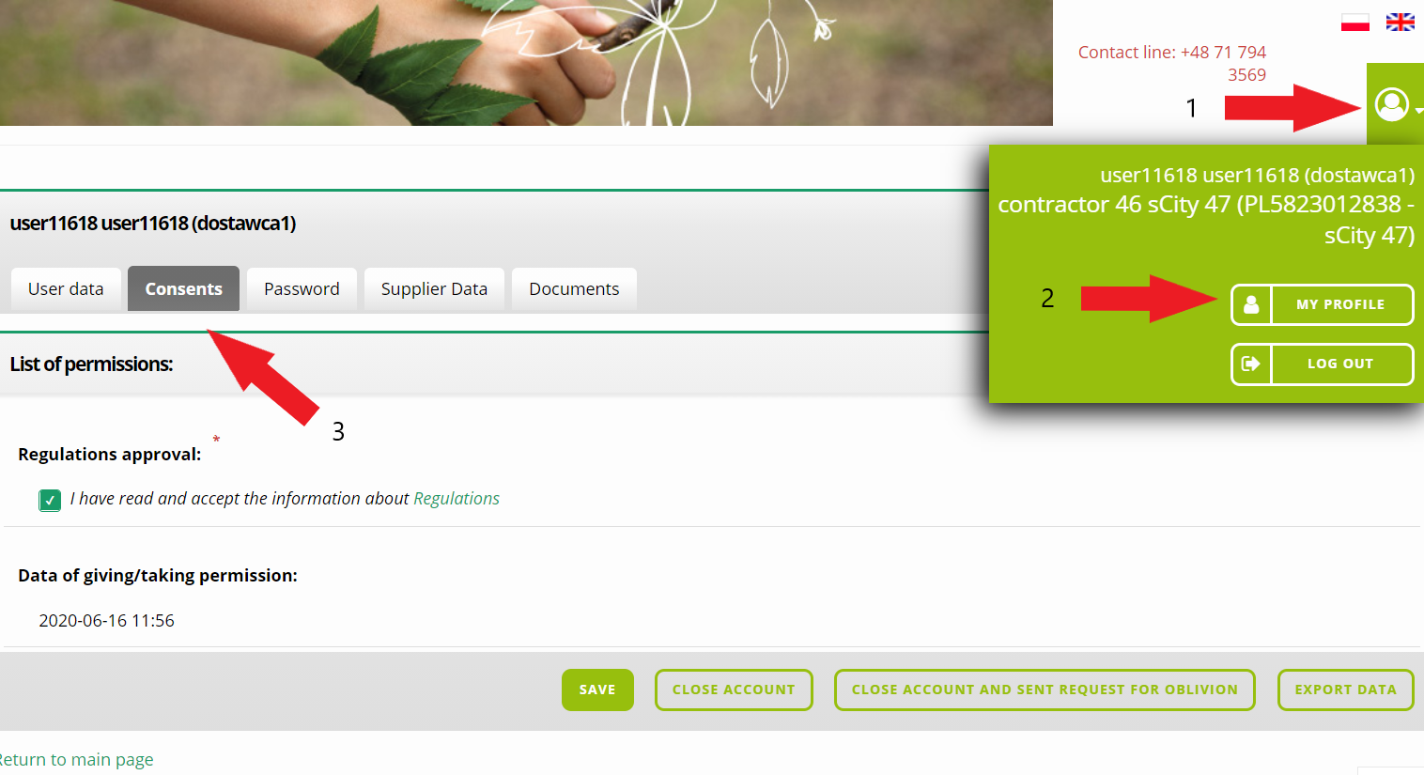

Public Zone

In the public area, you can view current and expired projects, information about the results in the section Terminated procedures, regulations of the purchasing process and Frequently asked questions (FAQ).
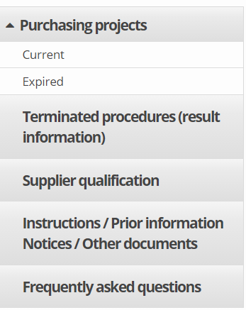

System navigation

The user interface of the Purchasing Platform consists of four basic elements:
- the header,
- user menu,
- the working area,
- footers.

- Header
In the header section there is a graphic logo of the Purchaser. There are basic information about the user's account. The next element visible in the header is the name, surname and login of the user and the name and identifier of the organizational unit where it is assigned.
The header has 2 functions: My Profile and Log out. Clicking on My profile, makes a screen with user data appears, but clicking on the Log out link, makes you finish your work with the system.

Above the menu, a sign allows you to hide menu items so that you can enlarge the working area of the application.
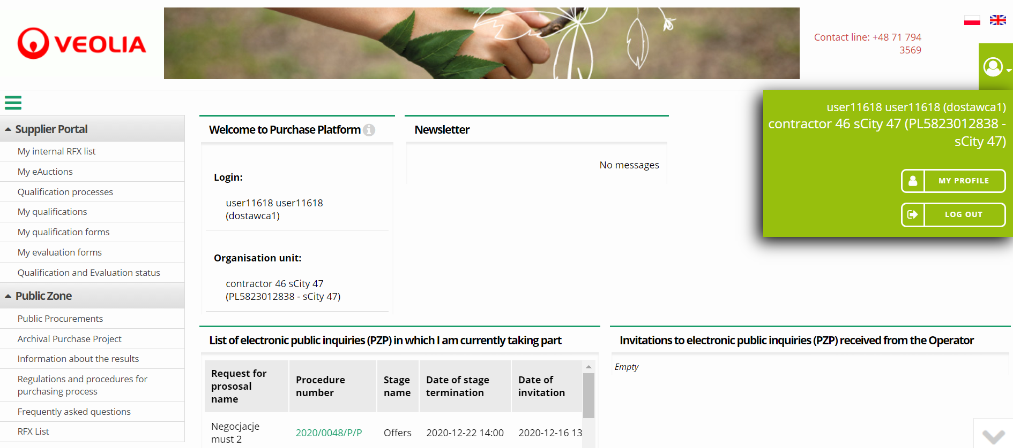

- User menu
Each section in user menu contains options to call up specific system screens. The range of options available in the menu depends on the user's privileges.
The menu has been equipped with a number of interactive functions to make it easier for users to work with the system. The first one is the function of roll-up/roll-up of the menu section content, activated by clicking on the section name.
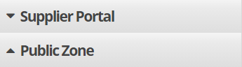

The working area can be enlarged by collapsing the menu or the system header.

- Footer
The footer contains information about the current system version.

- Actions
A context menu has been introduced in the lists. When you click on any item in the list, an additional menu develops.
icon for the view of details,
icon for data editing,
icon to delete the item,
icon for selecting list items/additions,
After logging into the platform, the user is automatically redirected to the Dashboard.
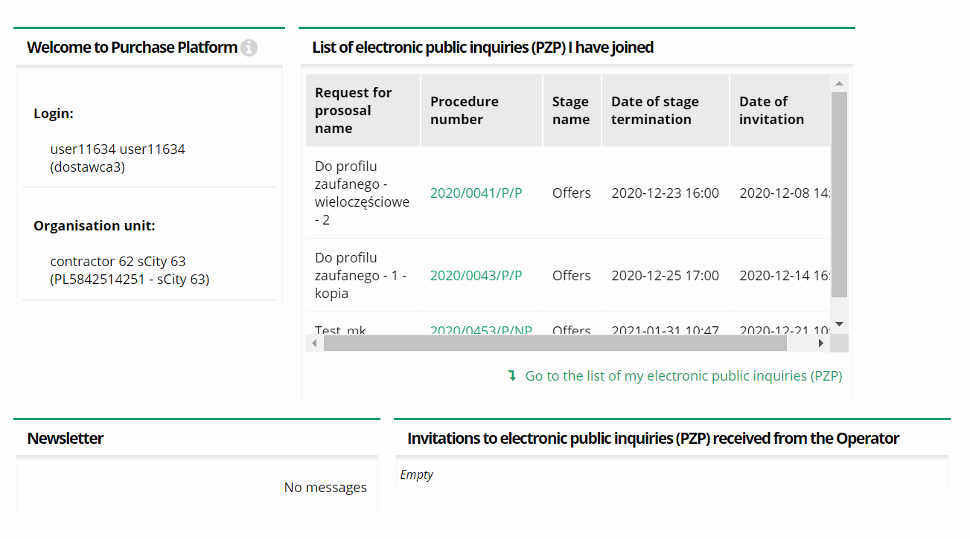
User can minimize, maximize and close selected boxes. It is possible to change the setting of the boxes within the work area. Move the cursor over the box and pull it to the desired location.
A box with the Welcome to Purchase Platform header informs about the basic data concerning the name of the User's Login and the organisational unit where the user belongs.
The Box with the header List of electronic public inquiries (PZP) I have joined - you will be assigned to this category automatically after performing certain actions in the proceedings, e.g:
- Inviting the Contractor to the proceedings by the Purchaser;
- Submitting a tender for the procedure;
- Asking a question during the procedure;
- Joining the open procedure.

Supplier Qualification process

Filling in the qualification form

According to the requirements of the Veolia Group, the supplier has to enter the qualification process by filling in the form. The assigned qualification is valid for a given calendar year, i.e. after completing it in order to participate in 1 procedure, the supplier does not have to repeat it until the end of the calendar year. Select the Qualification processes (1) in the Supplier Portal menu and then click on the qualification process started anywhere on this line (2).
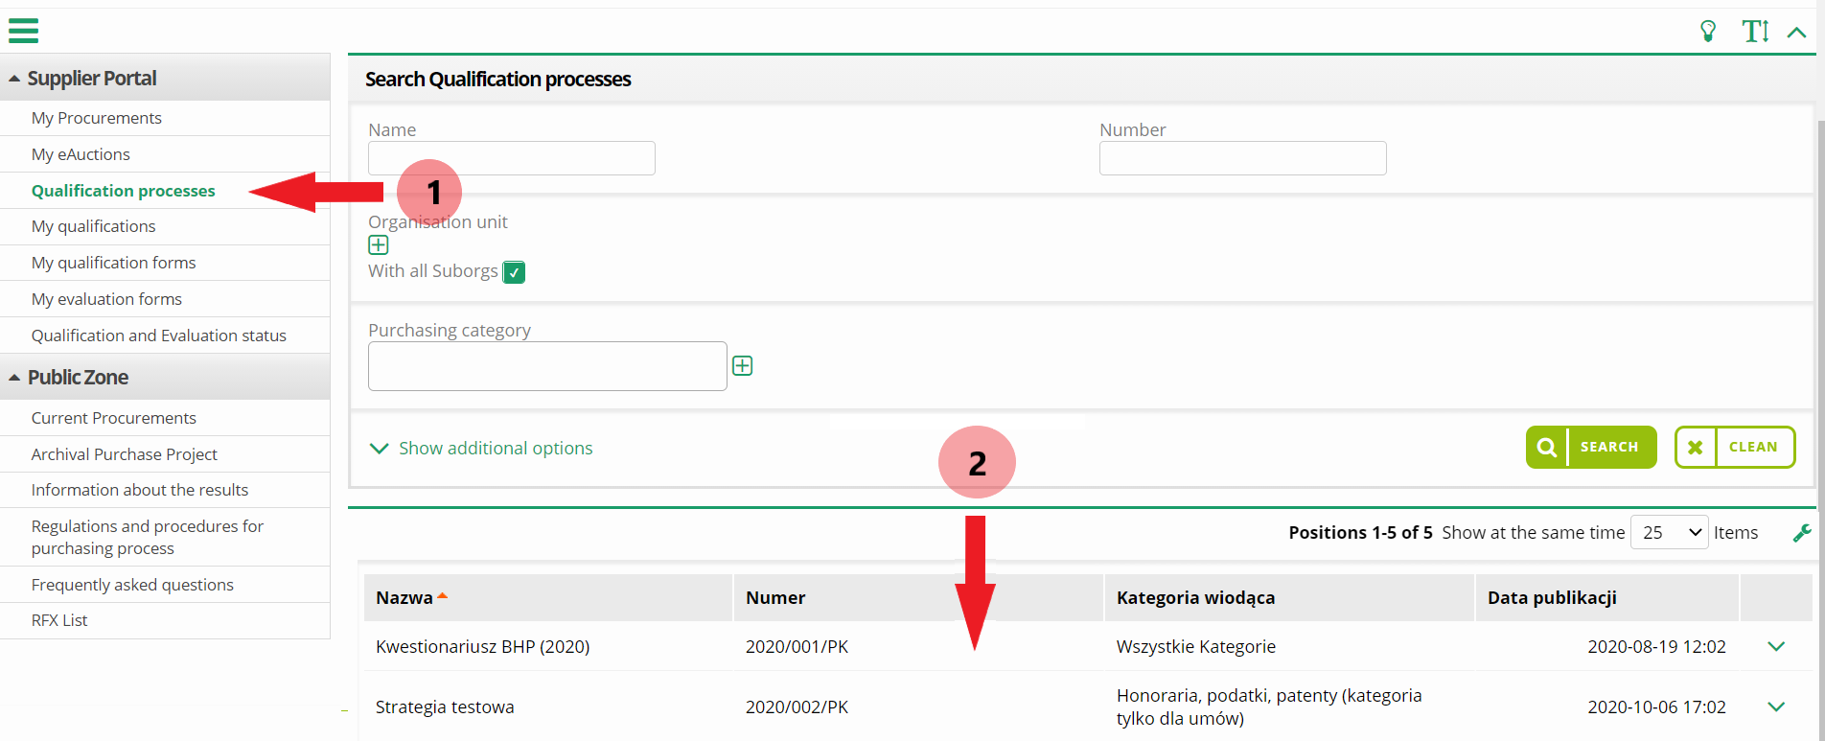

Then use the Qualify button.
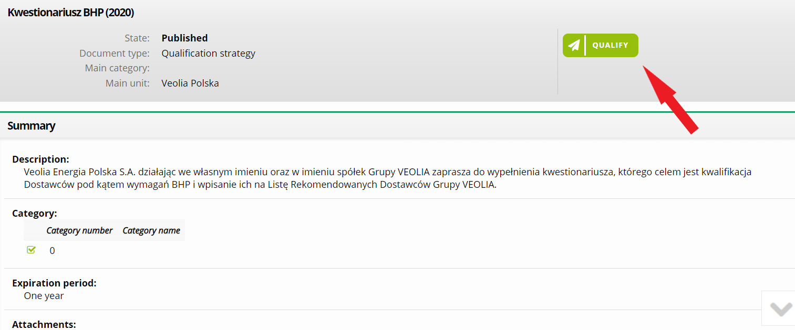

This will open a questionnaire form for the supplier to fill in. The user should save the form and send it. If he does not want to send it yet, he can return to it later - Save it.
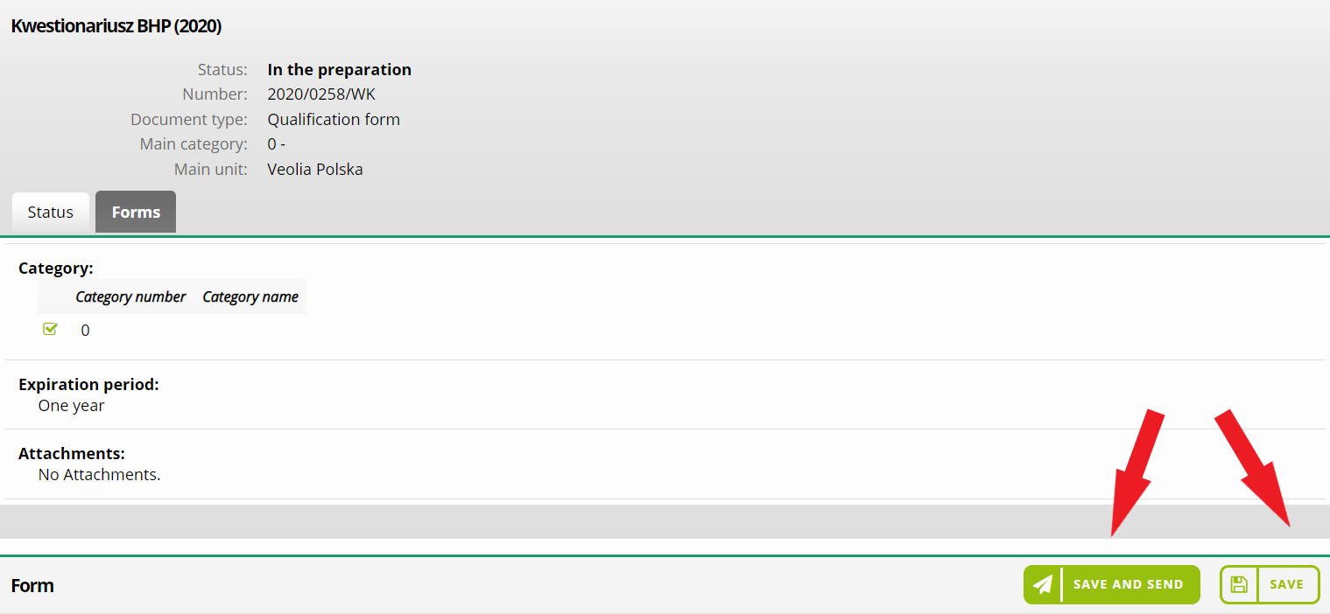

If you already want to send your form and use the Save and Send button, the system will ask you to confirm this action.
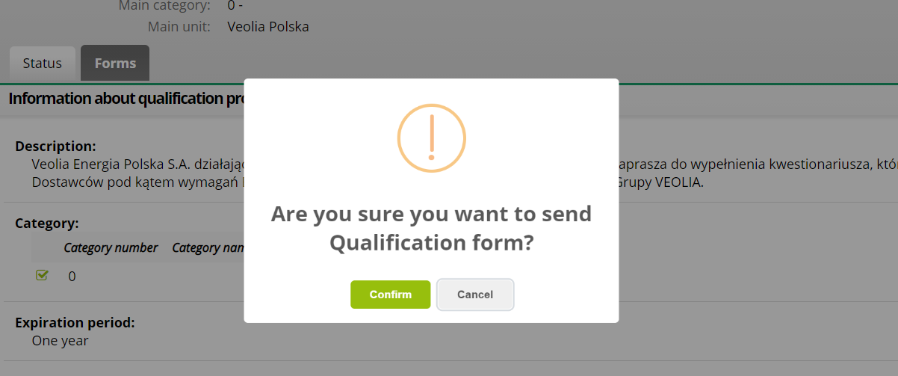

You have to select the form that was saved but not sent from the My Qualification forms Menu in order to return to an unsent but saved form later on.
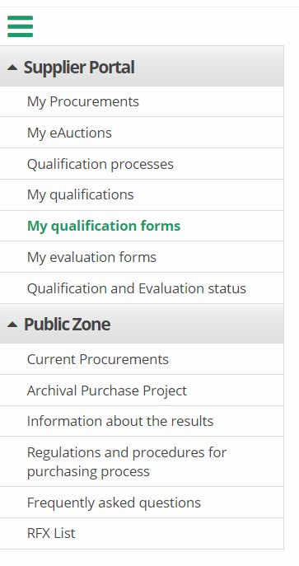
You can verify the status of your qualification process in the same way - it will be available after verification of the form by the purchaser. You can find this information on the Status tab. You can also check a comment on the result here.
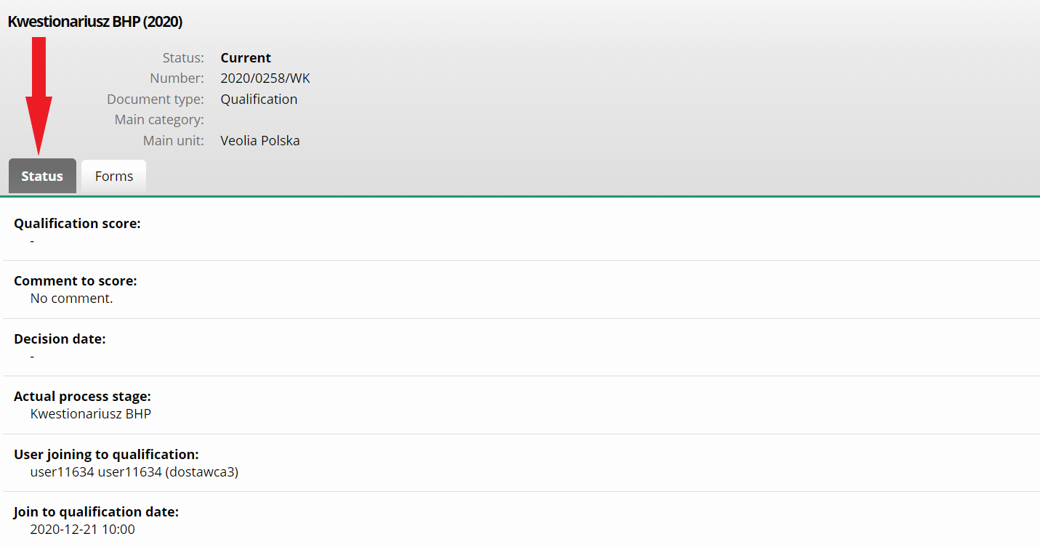

Making offers process

Participating in the proceedings

Contractor should log in to the system (OnePlace) in order to participating in the proceedings. After correct logging in, select the Supplier Portal section, then the Services section and select the Veolia Group Purchasing Platform - in accordance with the previous section. Then he should choose from the left-hand menu in the section Public Zone - Current Procurements (1). You can use the search engine to find the query you are interested in and click anywhere in the procedure line to look into details (2).
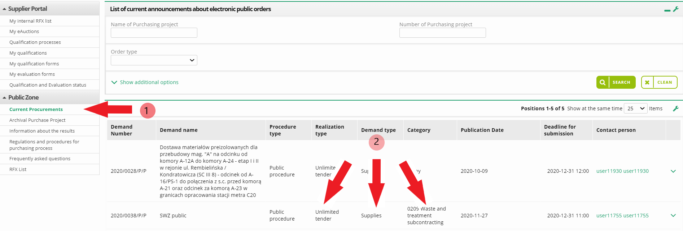

You will be moved to the screen with details of the procedure. You can read the details of the end date, Publication of a notice, Terms of Reference and other attachments.
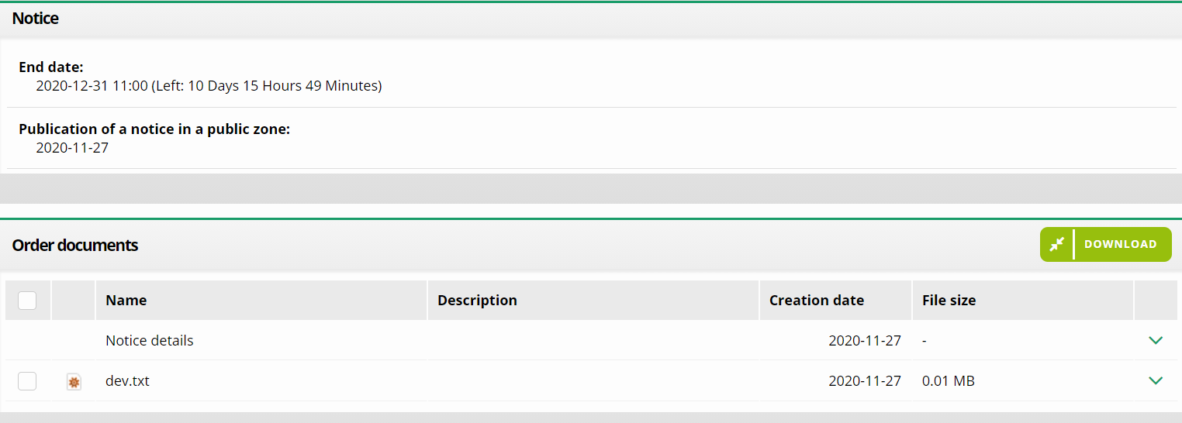

Click on the Join the procedure button to start making an offer.
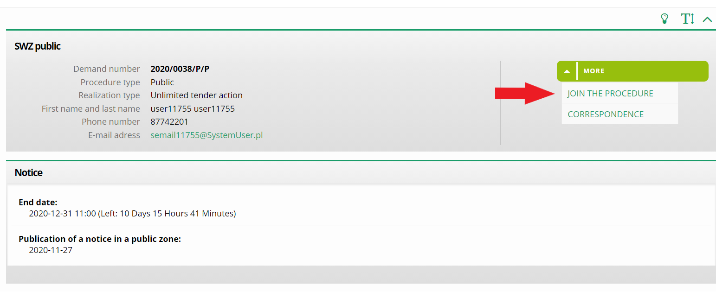

The procedure you have started will now be available in the My Procurements section in Supplier Portal menu and you will be redirected to the bidding screen.

Proceedings overview

The details of the Purchase Request (RFX) to which you are invited, or to which you have joined are placed in the four tabs below:
1. status;
2. order documents;
3. offers;
4. correspondence.

Heading of the Purchase Request (RFX)

The header includes information such as: Enquiry number, Project type (Public/Non-Public), Realization type (e.g.: Unlimited tender), name and surname, phone number and e-mail address of the Purchaser.
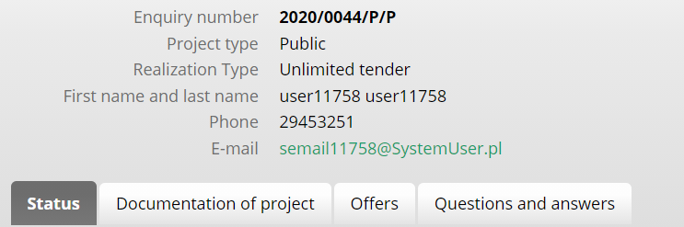

Status tab

On the Status tab you will find detailed information about the proceedings grouped into sections:
- Contact person details - this section contains information about the person responsible for the enquiry,
- Basic information - contains information on whether the round is open (each Economic Operator can join the round) or closed (for invited Economic Operators),
- Additional information - this section contains information on the currencies in which bids may be made,
- Information on electronic process rounds - Information on the stages and rounds of the request for proposal shall contain such data as:
- Name of the RFX round;
- Round number - After clicking on a round, the query will switch to that round (it is possible to preview previous rounds, or return to the current one, in which certain actions can be performed);
- The name of the round;
- Start date and end date - date and time from which contractors may submit tenders;
- The period of validity of the offer - date and time from which contractors may submit tenders;
- Round type - e.g. Auction, Standard / Open, Standard / Closed.

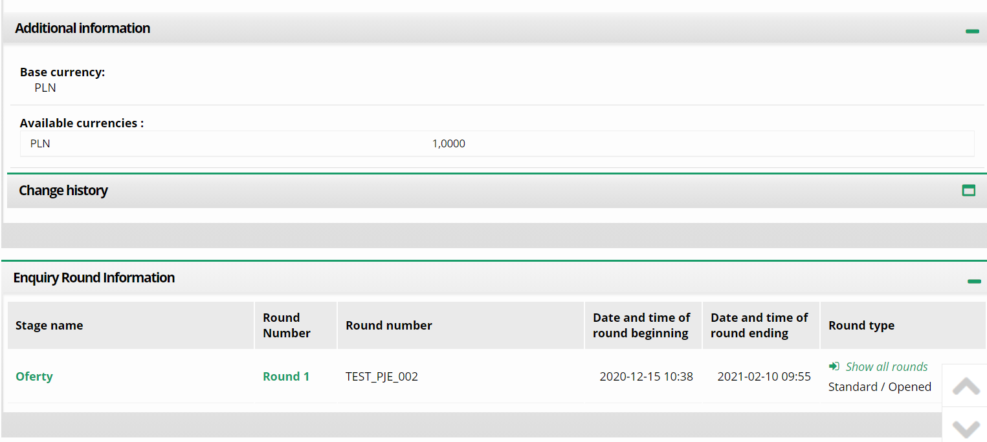

Project documentation tab

The Project Documentation tab contains information available also from the public area, before joining the procedure. The Notice section contains information on the End Date of the publication of the notice and the date of its placement in the public area. The Procurement Documents section includes documents which have been attached to the procedure (e.g.: ToR, Invitation to offer, etc.).
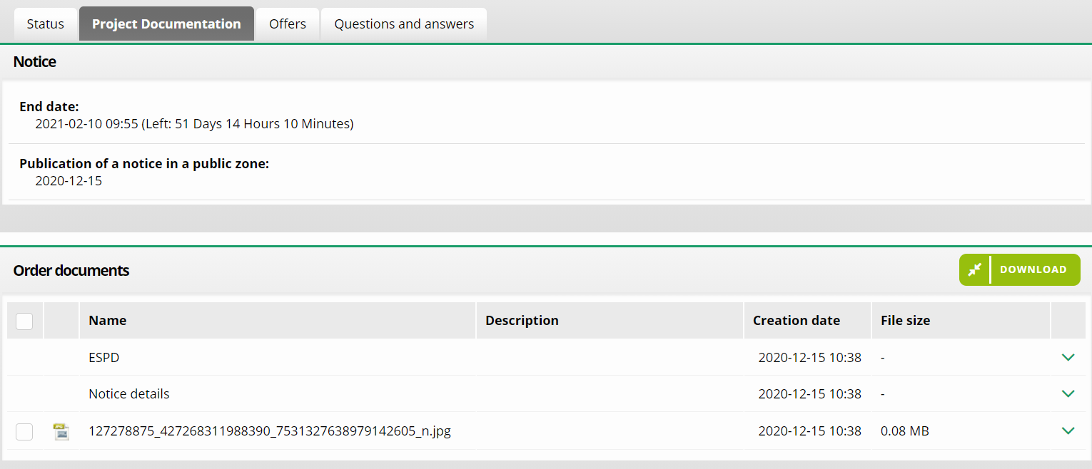

Click on the checkbox which is indicated by an arrow (on the above figure 33) in order to download attachments added to the proceedings. This action will mark all checkboxes with available documents. Then click on the selected Download button. If you are interested in one document, you can expand the context menu (by clicking the green arrow) and then click Download.

Offers tab – making an offer

The Offers tab contains a form for making an offer in the RFX. In order to make an offer, all required fields must be filled in. On the form there is a possibility to add files, make an offer and generate a report from the offer that you have made.
You should start by filling in the fields concerning the consortium and size of the company. 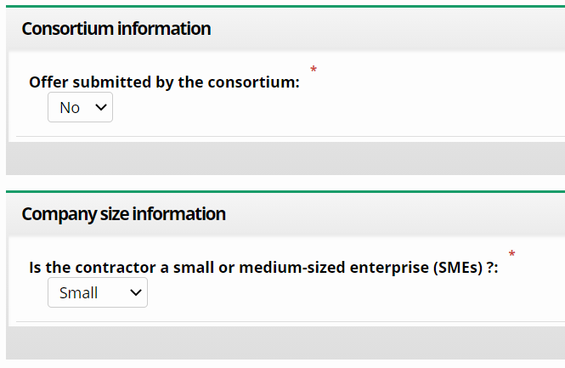
Then enter the number of subcontractors for the parts of the project (if there are any of them).
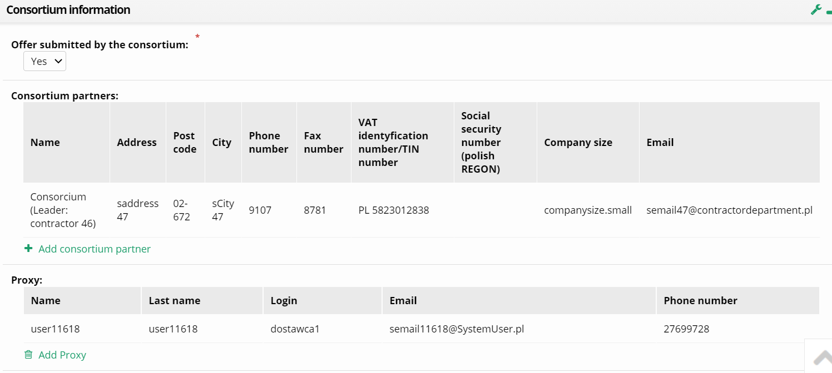

The screen below will change depending on the number of positions of the project. For the project with one position it will contain conditions of participation where you should choose the value Yes or No (1). Then enter a net (for non-public procurements) or net and gross unit price (for public procurements) (2). The system will calculate unit prices to the total value of the offer. The user may also add the document to the offer (3). After filling in the offer form, click Make an offer (4) or save the draft version. The possibility of saving a draft version of the offer before it is made is useful, for example, when you need to perform another action during making an offer. Then you will be able to return to complete the offer at a convenient time.
CAUTION! Saved offer is not a made one – it will not be taken into consideration during the process of evaluation of the offers.
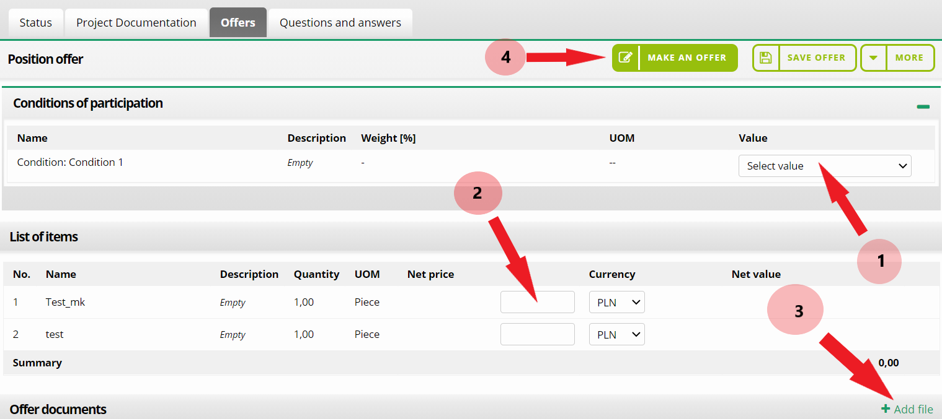

The offer and attachments submitted by the Contractor on the Purchase Platform in Public Procedures are not visible to the Purchaser until they are encrypted. After the opening date of the offers collection, the Purchaser has the possibility to decrypt the file and read its content.
You can use the calculator to calculate the net/gross price. After completing one of the net or gross box, click on the calculator icon and then indicate the VAT rate you are interested in. This option is available only for non-public procurements.
All the information considered as a business confidentiality should be enclosed on the Purchase Platform in a separate file together with a ticker of the document type - "Secret". The attachment is loaded by clicking the Add file button. In the same way, declarations with a qualified electronic signature, referred to in the regulation of the Minister of Development of 26 July 2016 on the types of documents which may be requested by the Contracting Authority from the Contractor in the contract award procedure (Journal of Laws of 2016, item 1126), submitted by the Contractor and other entities, on the capabilities or situations in which the Contractor relies on the principles specified in Article 22a of the PPL Act and by subcontractors, as well as any other documents which the Contractor wishes to submit to the Contracting Authority together with the procedure, are placed on the Platform.
For a procedure with many positions it will be necessary to fill in a form on each of the positions where the Supplier wants to make an offer. The user has 2 options to choose from:
- filling in the form in the system,
- generate an excel template and import the complete file.

Offers tab – filling in the form in the Platform

You have to find the position you are interested in on the list of positions and click anywhere in line (1) or the arrow at the end of line (2). Then, by choosing the Edit action, you can immediately open the details of the position in edit mode. At the first option, you have to open the form in the edit mode with the Edit button. Saved and submitted offers are put off in history. It is possible to generate documents which will enable the verification of these offers in a pdf file. Use the Generate offer history button (3).
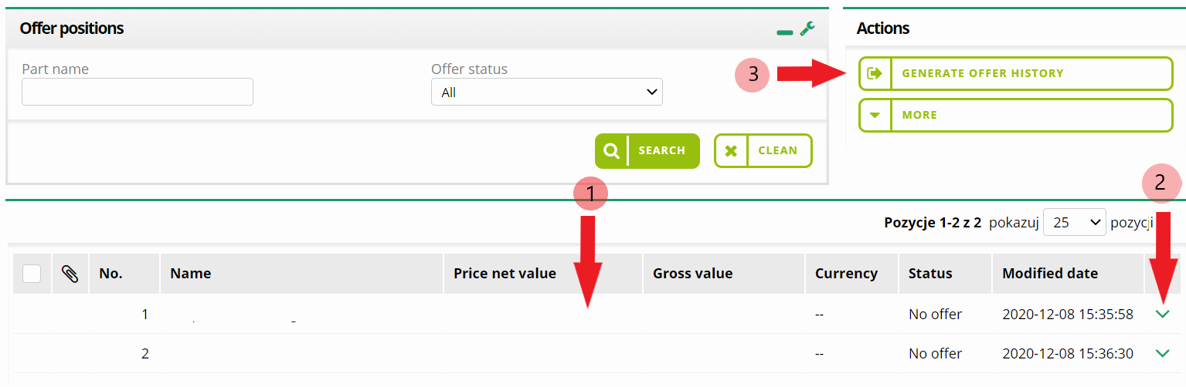
Now, fill in the obligatory fields and then click on the button Save and Exit (1). Then you will be redirected to the summary view after saving the offer.
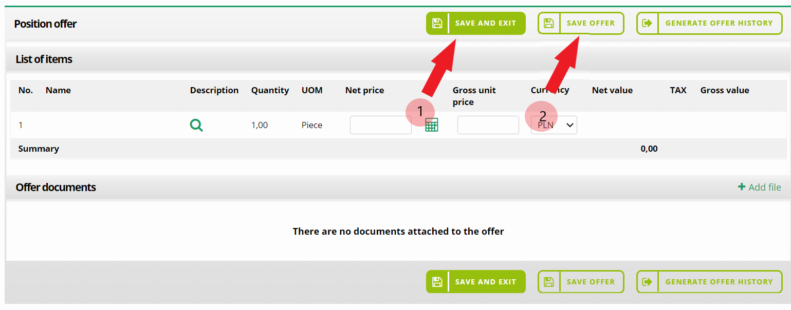
You can also save the draft version (2) and go to the next position.

Offers tab – generating an excel template and importing the completed file

Expand the list of available buttons and select Offer template (1) to fill in the offer form by importing an excel file. When the file is ready, on the same screen, select another option - Import offer (2).
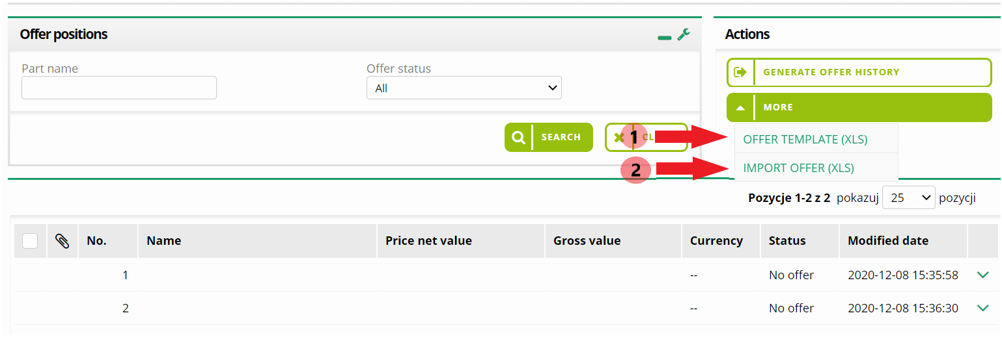

Making an offer in the procedures with many positions

After filling in the offer form the user must make an offer. Mark the selected positions (1) and use the Make an offer button (2).
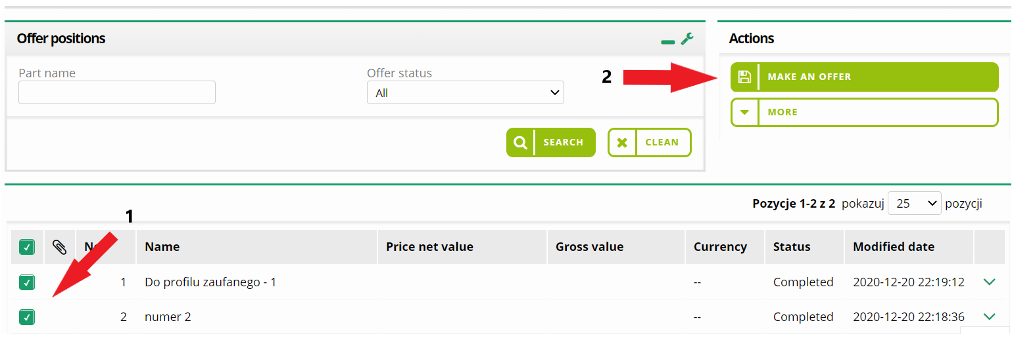

Offers modification and withdrawal

If you want to change the values in your saved or submitted offer, you need to enter the new values in the appropriate fields and then click on the Modify offer button. In order to withdraw an offer, you have to use the Withdraw the offer button. A new offer can be submitted until the end date has expired.
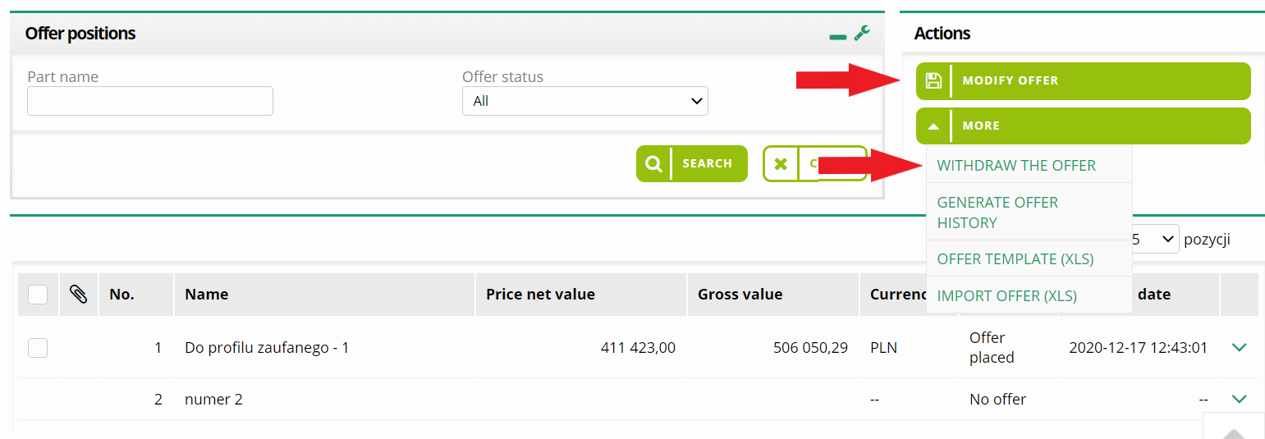

CAUTION! If you want to see your previous submitted amount, you have to use the Decrypt button and enter the password you have used during making the offer.

Offer encryption

The purchasing platform provides a function for automatically encrypting submitted offers. The password created by the contractor in such a way that no one except the person submitting the offer can see it before the end date of offers collection.
The System will first ask you for the password during making an offer, modifying an offer, withdrawing an offer or adding attachments. The message example is visible in the graphic below.
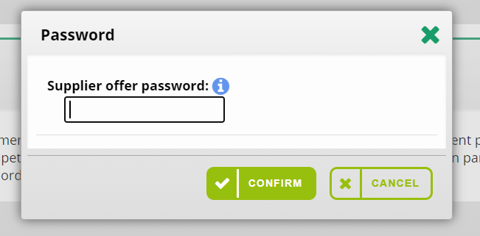

The contractor has full independence to invent an offer encryption password. It is very important for a contractor who makes an offer to remember or save the password to his offer accurately, because without this password it will be impossible to modify the offer made in the system. A user who forgets the password will have to withdraw his offer and place it again.

Electronic signature

What signature is required for a public procurement?
The signature is called qualified, i.e. verified by a qualified certificate. The same as it is used e.g. in contacts with ZUS ("Płatnik" programme).

Who is going to be the signature user?
The electronic signature is a personal signature, so it has to be issued per person. It must be a person who is authorised to make declarations of will on behalf of the company. If the signature is to be used by someone who is not shown in company documents (KRS, EDG) as a representative, the Contracting Authority should be informed about granting power of attorney by the Contractor to the designated person. The power of attorney may be granted e.g. for one proceeding only or for a specified period of time.

Who should I contact to get the signature?
A qualified electronic signature can be purchased from one of the suppliers, accredited by the Ministry of Digitization, e.g: Eurocert, KIR, PWPW, Certum by Asseco. The full list is available on the NcCert website. Signatures issued by qualified entities in any EU country are also binding. Both the device and the signature itself are ordered directly on the manufacturer's website. The procedure for the purchase and installation of the electronic signature - based on the CERTUM example - is available for download at the address:
https://www.certum.pl/pl/wsparcie/cert_wiedza_podpis_elektroniczny_zakup_zestaw_certum/
Installation procedures may vary from one signature manufacturer to another, but three main steps can be distinguished:
- Installing the software and the appropriate drivers for the readers on your computer - you must have an updated Java software;
- Insert the card into the reader to verify that the signature is working;
- Installing the appropriate certificates.

The certification path is a three-tier process of building trust in the signature: the signature user's certificate is certified by the Certification Centre. The certificate issued by the National Certification Centre then authorises the certificate by the Certification Centre.
Requirements for the computer used for electronic signature:
- PC/laptop computer with Windows 7/ 8/ 10 installed;
- MS Internet Explorer 10.0 (or higher) with Active X support, Firefox browser with Java support, encryption power: 128bit., Chrome browser, Opera.
- Internet connection: min. 1 Mb/s per computer (broadband Internet connection recommended);
- Connected or built-in to the computer cryptographic card reader issued by the issuer of the certificate used by the Contractor;
- Qualified certificate installed on the computer on which the Contractor will log in to the account (the certificate must be visible in the Windows certificate magazine (the logical magazine called "Personal" of Windows certificates);
- The latest version of Java Runtime Environment installed;
- No blocking of pop-up windows in the browser;
- Computer privileges for Java applet.

The procedure of signing an offer with the use of an electronic signature when submitting an offer by the Platform automatically starts the application with the signature and a document with the offer is generated. When approved, the signature takes place. In turn, the signature itself is confirmed with a PIN. After approval, the system automatically submits an offer.
In case of Google Chrome, Opera and Firefox (from version 52), it is required to install a dedicated extension Electronic Signature “Szafir” SDK and an additional application “Szafir” Host providing electronic signature functions. The “Szafir” SDK extension can be downloaded from location: Google Chrome:
https://chrome.google.com/webstore/detail/podpis-elektronicznyszaf/gjalhnomhafafofonpdihihjnbafkipc/
Opera:
https://addons.opera.com/pl/extensions/details/podpis-elektroniczny-szafir-sdk/
Firefox:
https://www.elektronicznypodpis.pl/download/webmodule/firefox/szafir_sdk_web-0.0.10-anfx.xpi
“The Szafir” Host installer for Windows 64bit from http://www.elektronicznypodpis.pl/gfx/elektronicznypodpis/pl/defaultstronaopisowa/146/1/1/szafirhost.msi.

Windows 32 bit from the location:
http://www.elektronicznypodpis.pl/gfx/elektronicznypodpis/pl/defaultstronaopisowa/146/1/1/szafirhost_x86.msi
After installing the “Szafir” SDK extension and the “Szafir” Host application, you should reload the current page. If the extension and the application have been installed correctly, and still problems occur while working with the signature, please check if the “Szafir” SDK extension is enabled in your browser and if the Java JRE environment is installed on your computer. You can download and install the Java JRE environment from the Java JRE location: https://www.java.com/download/.

Testing the electronic signature
In proceedings where a signature is required to make an offer, it is possible to check the correctness of operation before submitting an offer. You should choose the option test the signature, available in the upper right corner on the offers tab or after logging in to OnePlace in the left-hand menu.

Questions and answers tab

All communication between the Purchaser and the Contractors, including the possibility of providing information and questions to the ToR, is transmitted in electronic form via the Platform, under the Questions and answers tab.
There are two tabs among the Questions and answers tab: questions received from the Purchaser and questions addressed to the Purchaser.
The question to the Purchaser can be uploaded using the Add a question button.
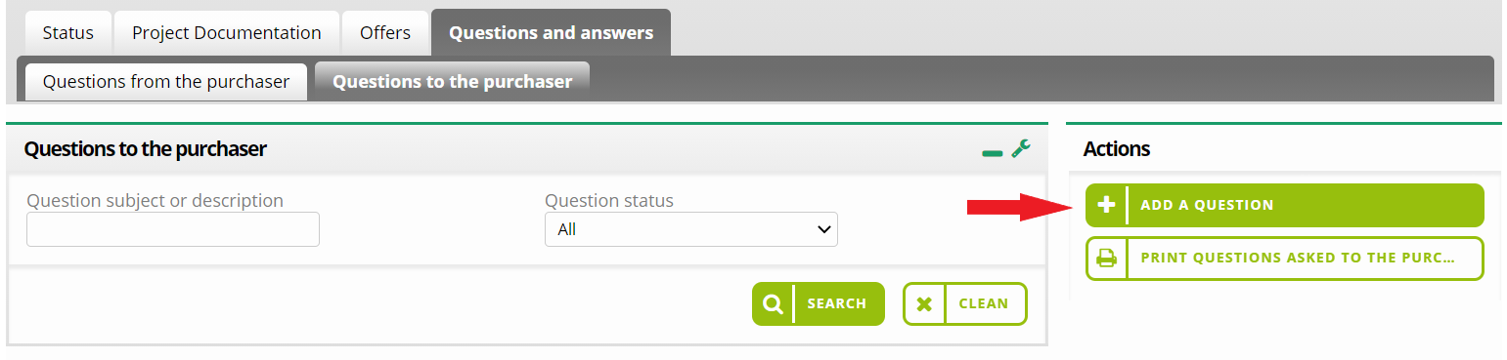

The question form consists of two mandatory fields: Question subject and Question description. You can also add an attachment. After filling the form, you must save your changes.
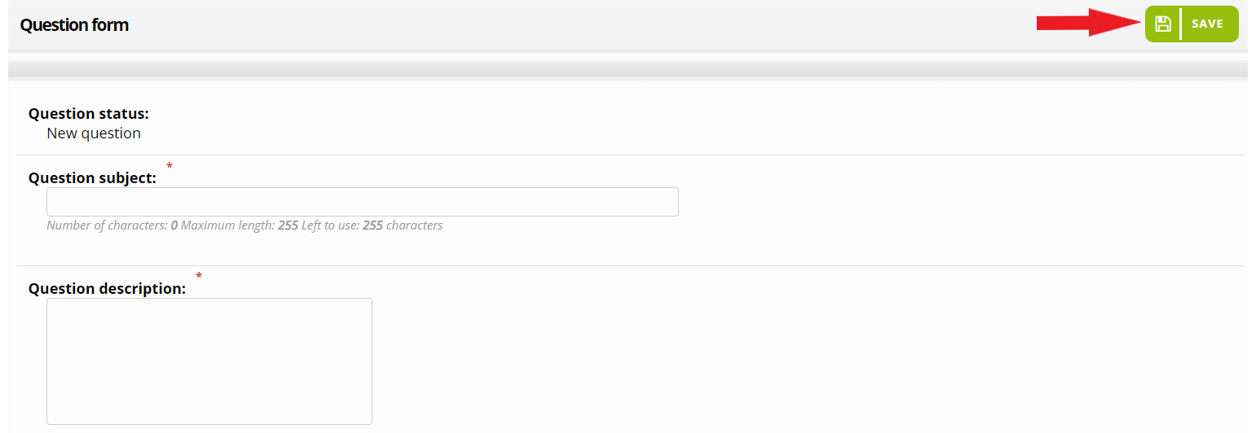

Then click Send the question to the Purchaser or modify it via Edit button.
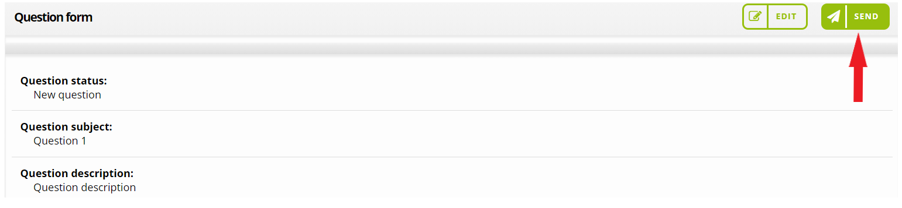

The status of the question on the list of Questions to the purchaser changes to Received when the purchaser answers the question. You can read the answer by clicking on the question details. If you receive the question from the purchaser, the message appears in the list of Questions from the purchaser. Use the arrow icon at the end of the line (1), expand the context menu and then click on the option Answer the question from the purchaser (2). Then fill in the form and send the answer to the purchaser.
